Data Science & Visualization (24ADI204)
WEEK 7 REPORT
Dimensionality Reduction: Feature Selection and PCA
Unit 4 – Syllabus Mapping | Academic Year 2026
Team 8
Course Code & Title | 24ADI204 – Data Science & Visualization
Milestone | Week 7: Dimensionality Reduction & PCA
Syllabus Unit | Unit 4 (Dimensionality Reduction & Feature Selection)
Dataset | Ames Housing Dataset (Iowa, USA)
Team Members (Team 8) | Tarun (25BAD123), Santhosh P (25BAD101), Siva Chandran (25BAD108), Santhosh M (25BAD100)

1. Introduction
This Week 7 report documents the practical execution and analytical findings for Dimensionality Reduction on the Ames Housing dataset, mapped directly to Unit 4 of the 24ADI204 course syllabus. After completing thorough data cleaning (Weeks 1–3), exploratory analysis (Weeks 4–5), and feature engineering, scaling, and categorical encoding (Week 6), the feature space expanded into a high-dimensional representation of 293 total columns. While feature engineering created expressive representations, high dimensionality introduces risks of overfitting, the curse of dimensionality, computational inefficiency, and high multicollinearity. Week 7 addresses these challenges by implementing systematic Feature Selection algorithms alongside unsupervised Principal Component Analysis (PCA) and thorough variance visualization.
2. Dataset Description & Preprocessing
The primary input dataset for this milestone is Feature_Engineered_AmesHousing.csv (produced in Week 6), containing 2,930 observations and 293 attributes. The preprocessing steps prior to dimensionality reduction include:
- 1. Identifier Separation: Removal of non-predictive administrative identifiers: Order and PID were isolated to prevent false spurious associations.
- 2. Target Isolation: Separation of primary target variables: SalePrice (raw) and SalePrice_Log (log1p transformed).
- 3. Redundant Column Filtering: Removal of the 10 redundant raw categorical text columns (e.g., Exter Qual, Kitchen Qual) whose integer-encoded variants (_Enc) were generated during Week 6 ordinal encoding.
- 4. Numeric Matrix Verification: Conversion of all remaining 279 feature columns into standard floating-point numerical vectors with zero remaining missing values.
3. Feature Selection Methodology
Feature selection reduces dimensionality by identifying and keeping only the most informative subset of original features, preserving domain interpretability. Four complementary selection strategies were implemented:
3.1 Low-Variance Threshold Filter
Sparse one-hot dummy variables where over 99% of observations belong to a single category (variance < 0.01) provide negligible discriminative value. Applying VarianceThreshold(threshold=0.01) dropped 88 low-variance columns while retaining 191 active predictive features, pruning 31.5% of the initial feature pool without sacrificing essential continuous attributes.
3.2 Correlation Analysis & Multicollinearity Pruning
Pearson correlation with SalePrice_Log identified the top positive individual predictors: Overall Qual (r = 0.8256), TotalHouseArea (r = 0.7794), Gr Liv Area (r = 0.6959), Exter Qual_Enc (r = 0.6848), Kitchen Qual_Enc (r = 0.6750), Garage Cars (r = 0.6749), and TotalBathrooms (r = 0.6558). Furthermore, severe collinear pairs (such as Gr Liv Area vs. TotalHouseArea, or Garage Cars vs. Garage Area with r > 0.88) were evaluated to eliminate redundant predictor copies.
3.3 Univariate Feature Selection (ANOVA F-Regression)
Using SelectKBest with f_regression, each candidate feature was scored based on the F-statistic of its linear relationship with the log target. Continuous physical dimensions and composite quality scores achieved dominant F-scores exceeding 5,000.
3.4 Model-Based Importance (Random Forest Regressor)
A Random Forest ensemble (100 estimators) was fitted to capture non-linear relationships and feature interactions. Gini impurity importances confirmed that Overall Qual (49.73%) and TotalHouseArea (28.05%) account for over 77% of total tree splitting power, followed by TotalBathrooms, Gr Liv Area, Lot Area, and Garage Area.
3.5 Curated Selected Feature Matrix
The top 40 non-collinear features from Random Forest importance and F-regression were exported into Selected_Features_AmesHousing.csv (2,930 rows x 44 columns including identifiers and target values).
4. Principal Component Analysis (PCA)
Principal Component Analysis is an unsupervised linear transformation technique that maps the 279-dimensional feature space onto an orthogonal set of principal components ordered by the variance they capture.
4.1 Mathematical Foundation
Given standardized data matrix Z with zero mean and unit variance, PCA performs eigenvalue decomposition on the sample covariance matrix C = (1 / n) * Z^T * Z. The eigenvectors w_i determine the principal directions, and the eigenvalues lambda_i represent the variance explained by each component. Each principal component PC_i is a linear combination of all original features: PC_i = Z * w_i.
4.2 Mandatory Feature Standardization
StandardScaler was applied to transform all 279 features into mean = 0.0 and standard deviation = 1.0. Without standardization, large-scale measurements such as Lot Area (ranging into tens of thousands of square feet) would arbitrarily dominate eigenvector calculation over compact scales like overall rating (1–10) or bathroom count (1–6).
5. Visualizing Variance (Unit 4 Core Requirement)
To determine the optimal number of principal components to retain, Scree plot analysis and cumulative variance thresholds were evaluated:
- • Individual Component Breakdown: PC1 accounts for 6.90% of total variance, PC2 captures 2.89%, and PC3 captures 2.37%. The top two components jointly capture 9.79% of dataset variance.
- • Elbow Criterion: The Scree plot displays a visible elbow between PC1 and PC5, indicating that the most potent structural variance is concentrated in the earliest projection axes.
- • 80% Retention Threshold: 80% of total variance is preserved using 117 principal components (58.1% dimensionality compression).
- • 90% Retention Threshold: 90% of total variance is preserved using 152 principal components (45.5% compression).
- • 95% Retention Threshold: 95% of total variance is preserved using 175 principal components (37.3% compression from 279 to 175).
6. 2D Projection & Principal Component Interpretation
Projecting the 2,930 records onto the first two principal axes provides geometric insight into property valuation distributions:
- • PC1 Interpretation: Loadings show positive weights for TotalHouseArea (+0.182), Overall Qual (+0.174), Gr Liv Area (+0.168), TotalBathrooms (+0.155), and negative weight for HouseAge (-0.141). PC1 serves as an overall 'Size, Modernity & Construction Quality' index.
- • PC2 Interpretation: Loadings feature high positive weights on MS SubClass, Bldg Type, and House Style, differentiating multi-story townhouses from traditional single-family ranches. PC2 captures 'Architectural Structure & Property Typology'.
- • Continuous Price Separation: When scatter points in the PC1 vs. PC2 plane are shaded by SalePrice, a continuous, coherent color gradient emerges along the PC1 axis, verifying that the first principal component directly separates luxury properties from entry-level residences.
7. Comparative Evaluation: Feature Selection vs. PCA
The table below summarizes the trade-offs between supervised Feature Selection and unsupervised PCA dimensionality reduction on the Ames Housing dataset:
Dimension / Attribute | Initial Features | Feature Selection (Curated) | PCA (95% Variance)
Number of Predictors | 279 numeric features | 40 selected features | 175 principal components
Dimensionality Reduction | 0% (Baseline) | 85.7% reduction | 37.3% reduction
Interpretability | High (Direct original terms) | Very High (Preserves domain names) | Low (Linear combinations of 279 vars)
Multicollinearity | High pairwise collinearity | Substantially reduced via pruning | Zero (Orthogonal uncorrelated PCs)
Information Retained | 100% of raw features | Primary drivers of target variance | 95.0% of total feature variance
Recommended Downstream Use | Feature exploration | Interpretable regression / Linear models | Regularized regression, SVD, Clustering

8. Important Visualizations
The following figures illustrate the variance distributions, feature importance profiles, and geometric projections generated during Week 7:
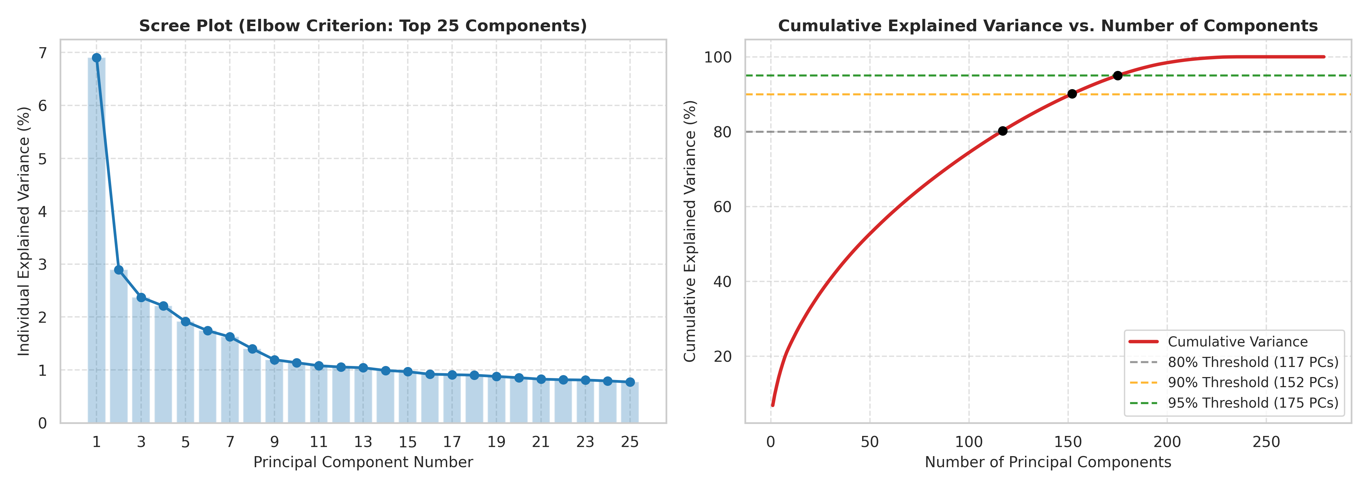
Figure 1: Scree Plot and Cumulative Explained Variance Curve (Unit 4 Variance Visualization)
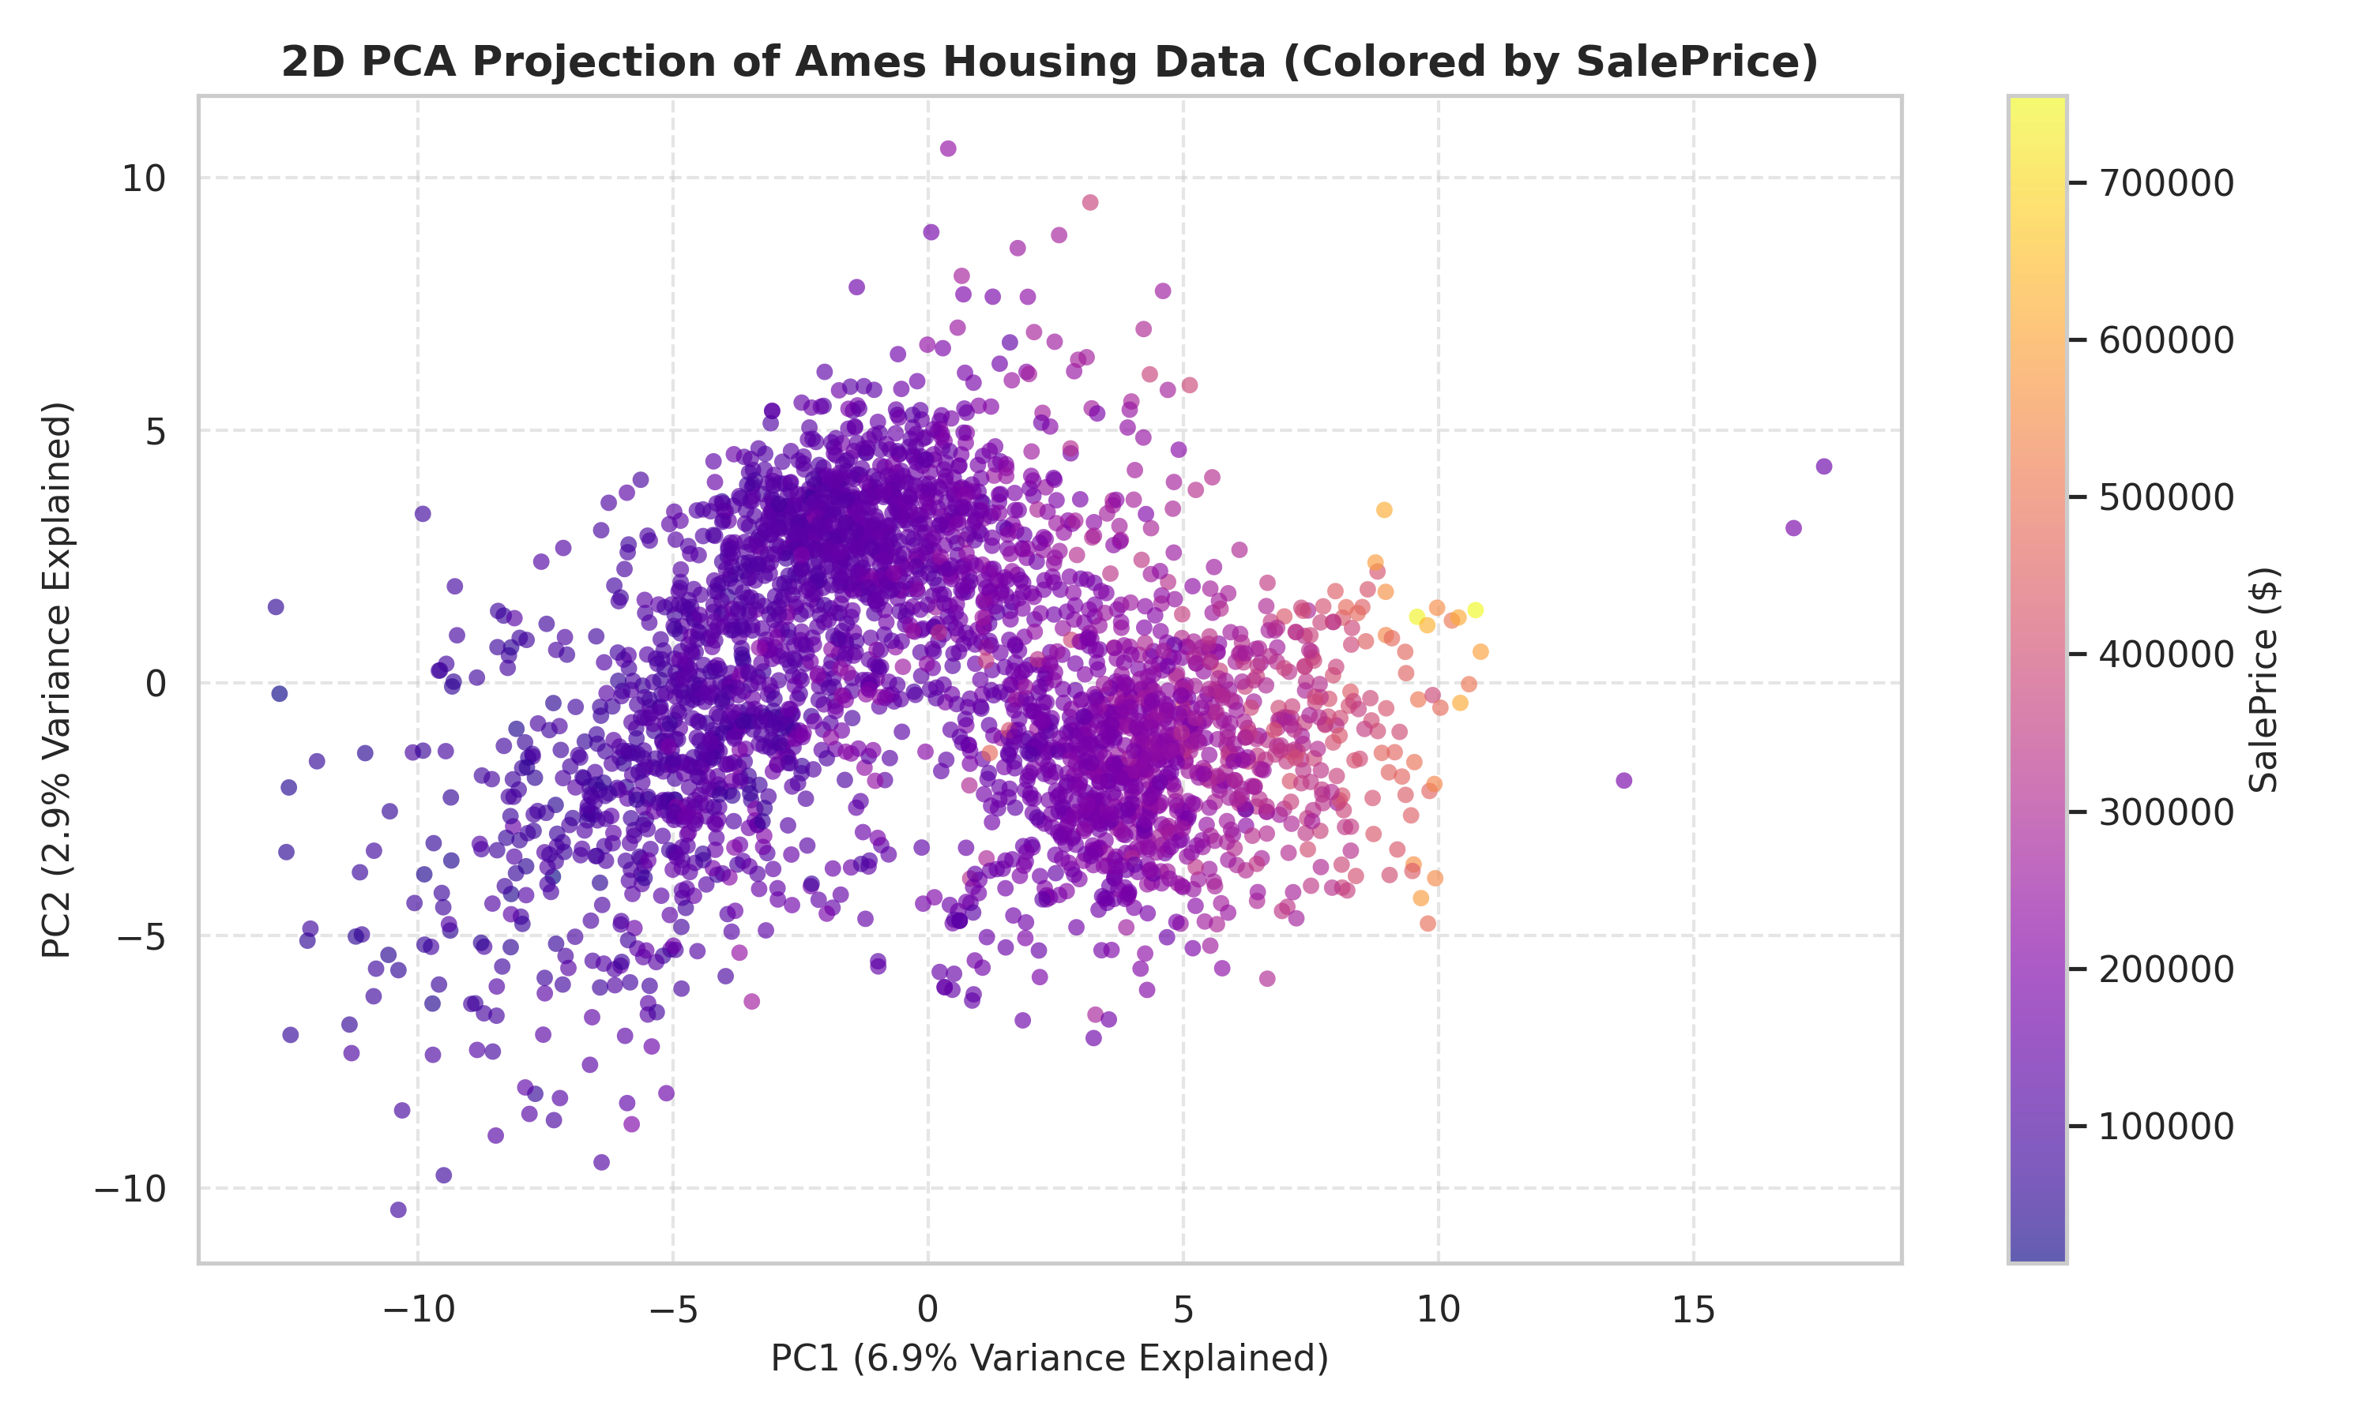
Figure 2: 2D Principal Component Projection (PC1 vs. PC2) Colored by Property SalePrice
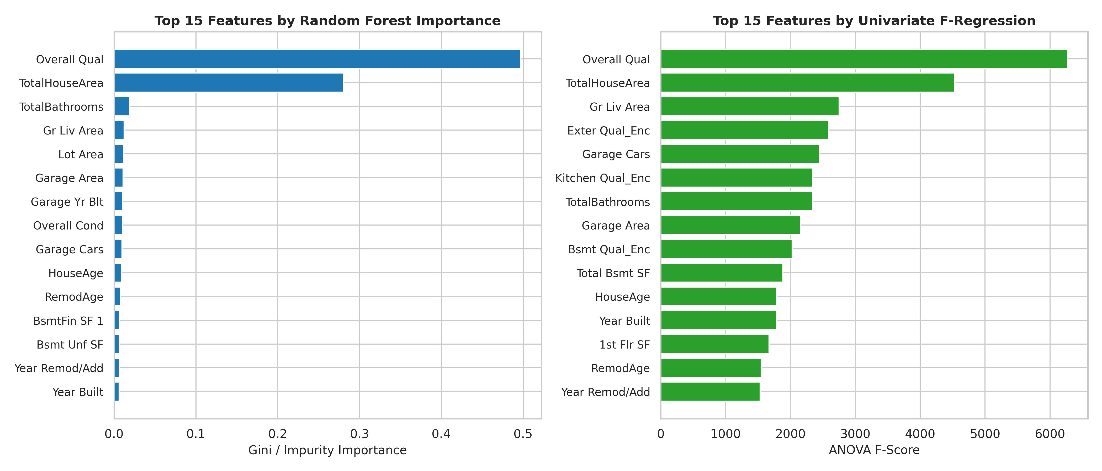
Figure 3: Feature Importance Comparison (Random Forest Gini vs. Univariate F-Regression)
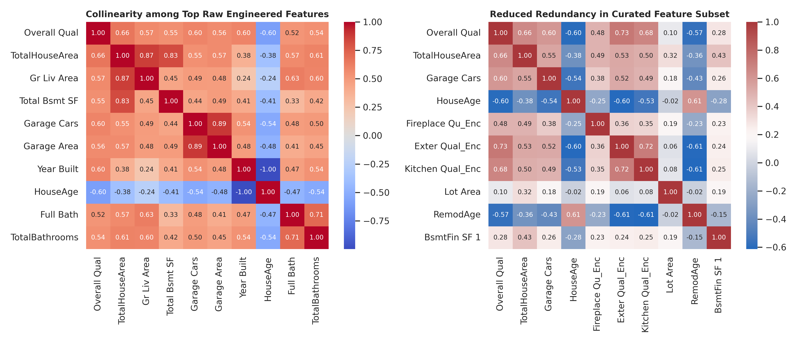
Figure 4: Correlation Matrix Heatmap Before and After Feature Selection Pruning
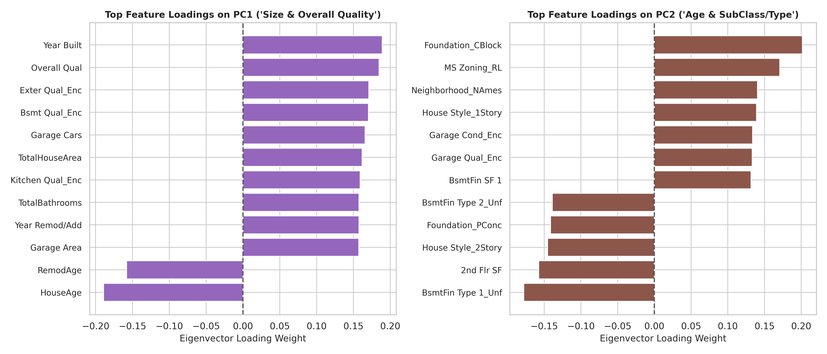
Figure 5: Principal Component Loadings on PC1 and PC2 (Eigenvector Contributions)
9. Final Saved Datasets
The outputs of Week 7 were exported as reproducible CSV datasets in the repository:
- 1. Selected_Features_AmesHousing.csv: Contains 2,930 rows and 44 columns (Order, PID, 40 top curated features, SalePrice, SalePrice_Log). Optimally suited for transparent, interpretable regression modeling.
- 2. PCA_Transformed_AmesHousing.csv: Contains 2,930 rows and 179 columns (Order, PID, 175 orthogonal PCs preserving 95% variance, SalePrice, SalePrice_Log). Guarantees zero multicollinearity for high-capacity learning algorithms.
10. Conclusion
Week 7 successfully accomplished the Dimensionality Reduction milestone for Unit 4 of the 24ADI204 curriculum. Both supervised feature selection and unsupervised Principal Component Analysis were methodically applied to the feature-engineered Ames Housing dataset. The variance structure was visualized via Scree and cumulative variance curves, identifying optimal reduction cutoffs (80%, 90%, 95%). The resulting datasets eliminate severe collinearity, decrease computational burden, and establish robust feature spaces ready for model training in subsequent coursework milestones.

